PROGRAM 3

Find greatest of three numbers using classes.

CODE:

#include <iostream>

#include <climits>

using namespace std;

class num

{

public:

int a,b,c;

void input()

{

cout<<"ENTER A B AND C"<<endl;

cin>>a>>b>>c;

}

void maxi()

{

int max=INT_MIN;

if(a>max)

{

max=a;

}

if(b>max)

{

max=b;

}

if(c>max)

{

max=c;

}

cout<<"MAXIMUM IS "<<max<<endl;

}

};

int main() {

class num num1;

num1.input();

num1.maxi();

return 0;

}

OUTPUT:

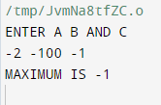

PROGRAM 4

Write a class which creates an array and search a number in that array

CODE:

#include <iostream>

using namespace std;

class array

{

public:

int arr[100];

int len;

void input()

{

cout<<"ENTER THE NUMBER OF ELEMENTS YOU WANT"<<endl;

cin>>len;

cout<<"ENTER THE ARRAY ELEMENTS"<<endl;

for(int i=0;i<len;i++)

{

cin>>arr[i];

}

}

int search(int key)

{

for(int i=0;i<len;i++)

{

if(key==arr[i])

{

return i;

}

}

return -1;

}

};

int main() {

// Write C++ code here

class array arr;

arr.input();

int key;

cout<<"ENTER KEY"<< endl;

cin>>key;

int result=arr.search(key);

if(result==-1)

{

cout<<"NOT FOUND"<<endl;

}

else

{

cout<<"RESULT FOUND AT INDEX "<<result<<endl;

}

return 0;

}

OUTPUT:

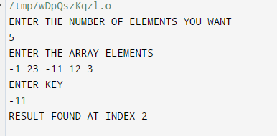

PROGRAM 5

Write a C++ program to create three objects for a class named pntr_obj with data members such as roll_no &name . Create a member function set_data() for setting the data values and print() member function to print which object has invoked it using ‘this’ pointer.

CODE:

#include <iostream>

using namespace std;

class pntr_obj

{

private:

int roll_no;

string name;

public:

void set(int roll_no,string name)

{

this->roll_no=roll_no;

this->name=name;

}

void print()

{

cout<<"ROLL NO IS "<<roll_no<<endl;

cout<<"NAME IS "<<name<<endl;

}

};

int main() {

class pntr_obj o1;

o1.set(2122,"Avni");

o1.print();

return 0;

}

OUTPUT:

